MATLAB SIMULATION OF SUPERHETERODYNE RECEIVER FOR AM COMMUNICATION SYSTEM WITH FREQUENCY MIXING AND FILTERING

OBJECTIVES:
i) To model and simulate the operation of a superheterodyne receiver for an AM communication system using MATLAB by implementing frequency mixing and intermediate frequency (IF) signal generation.
ii) To recover the original message signal through intermediate frequency filtering and envelope detection, and analyze the waveforms of the message, carrier, AM, IF, and recovered signals.
PROGRAM (MATLAB CODE):
clc;
clear;
close all;
% Parameters
fs = 100000;
t = 0:1/fs:0.02;
% Frequencies
fc = 10000; % Carrier frequency
fm = 400; % Message frequency
fi = 5000; % Intermediate frequency
flo = fc + fi; % Local oscillator frequency
% 1. Message Signal
m = cos(2*pi*fm*t - pi/3);
% 2. Carrier Signal
c = cos(2*pi*fc*t);
% 3. AM Signal
rf = (1 + m).*cos(2*pi*fc*t);
% 4. Mixer and IF Signal
lo = cos(2*pi*flo*t);
mixed = rf .* lo;
% Approximate IF signal for display
if_signal = 0.5*(1 + m).*cos(2*pi*fi*t);
% 5. Demodulation
demod = if_signal .* 2.*cos(2*pi*fi*t);
% Low-pass filtering using moving average
output = movmean(demod, 100);
% Remove DC component to recover message
output = output - mean(output);
% Normalize recovered signal
output = output / max(abs(output));
% Plot all signals
figure('Color','w');
subplot(5,1,1);
plot(t,m,'b','LineWidth',1);
title('Message Signal');
xlim([0 0.02]);
ylim([-1.1 1.1]);
grid on;
subplot(5,1,2);
plot(t,c,'b','LineWidth',1);
title('Carrier Signal');
xlim([0 0.02]);
ylim([-1.1 1.1]);
grid on;
subplot(5,1,3);
plot(t,rf,'b','LineWidth',1);
title('AM Signal');
xlim([0 0.02]);
ylim([-2 2]);
grid on;
subplot(5,1,4);
plot(t,if_signal,'b','LineWidth',1);
title('Intermediate Frequency (IF) Signal');
xlim([0 0.02]);
ylim([-1.1 1.1]);
grid on;
subplot(5,1,5);
plot(t,output,'b','LineWidth',1);
title('Recovered Signal');
xlabel('Time (s)');
xlim([0 0.02]);
ylim([-1.1 1.1]);
grid on;
% Display frequency values
fprintf('RF Frequency = %d Hz\n',fc);
fprintf('Message Frequency = %d Hz\n',fm);
fprintf('IF Frequency = %d Hz\n',fi);
fprintf('Local Oscillator Frequency = %d Hz\n',flo);

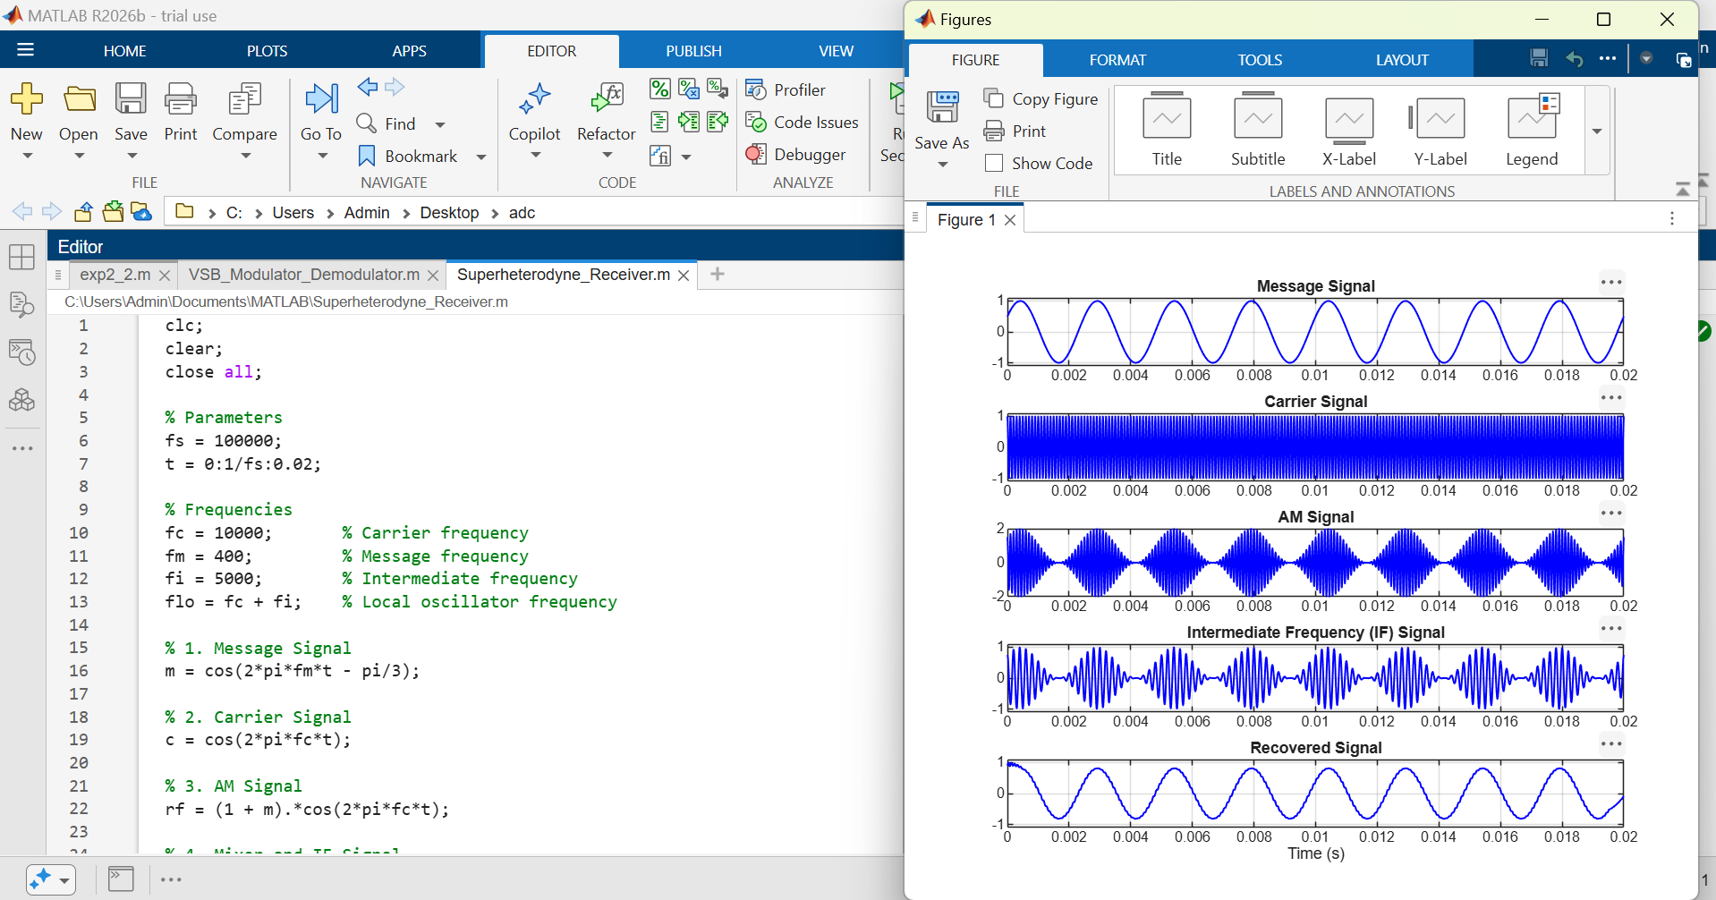
OUTPUT (GRAPH)

RESULT:
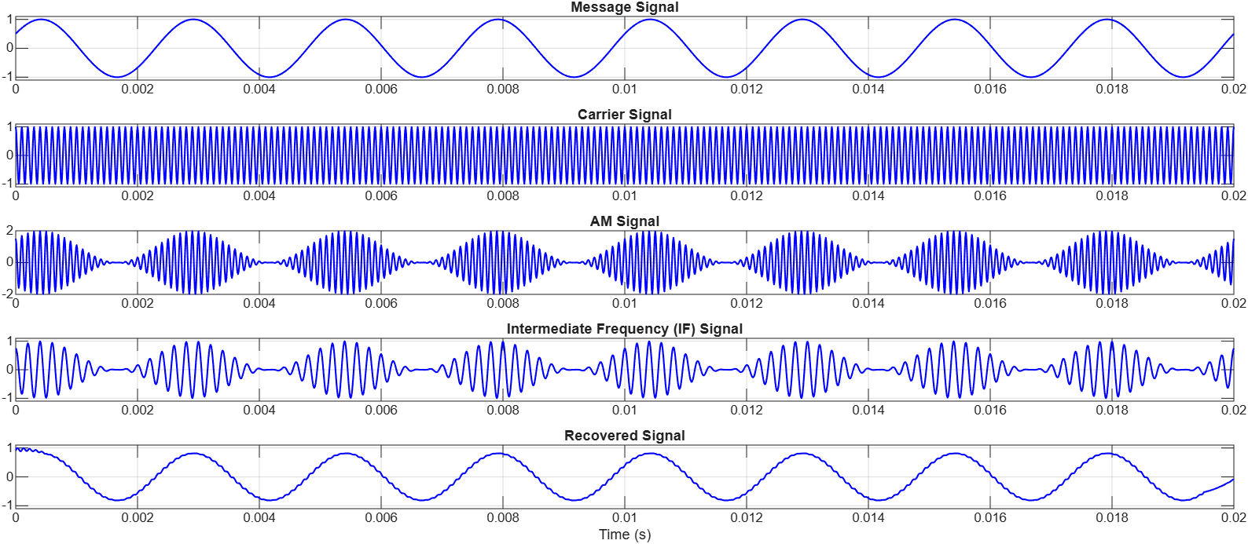
The superheterodyne receiver was successfully simulated in MATLAB, and the message signal, carrier signal, AM signal, Intermediate Frequency (IF) signal, and recovered signal were obtained through frequency mixing and filtering.

